Skenandoa House
On Campus Housing
Room | Rate/Person *
Single | 65.00

- Approx 30 spaces available : 13 singles, 16 in double occupancy
- Private bath and shower
- Air conditioned
- Wireless access
- Located somewhat downhill from campus. The climb is rather steep
- Lovely common room and kitchen facility
- Bed linens and hangers provided
- Ironing boards & irons available upon request
- Non-smoking only

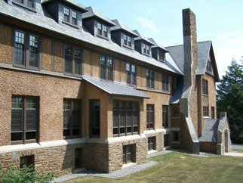 | 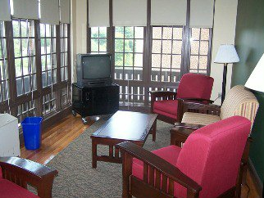
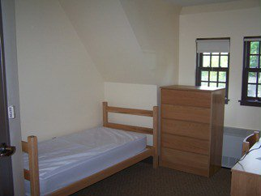 | 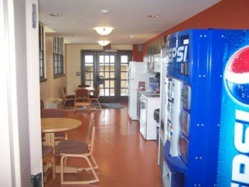
Wertimer House
On Campus Housing
Room | Rate/Person *
Double | $35.00

- Occupancy 46 guests in double occupancy
- Hall baths
- Fans provided. Not an air conditioned space
- Ample parking next to dorm
- Wireless access
- Adjacent to Skenandoa –other conference res hall.
- Large common room on first floor and kitchen facility
- Bed linens and hangers provided
- Irons and ironing boards available upon request
- Non-smoking only
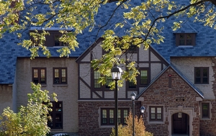 | 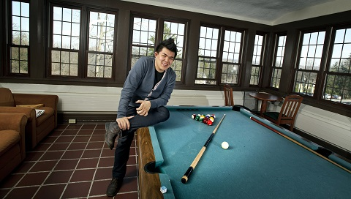
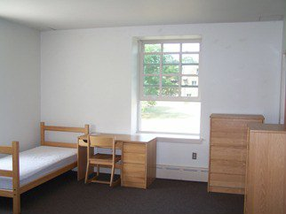

South Residence Hall
On Campus Housing
Room | Rate/Person *
Double | $45.00

- Occupancy 60 guests in double occupancy
- Bath and shower in rooms
- Fans provided. Not an air conditioned space
- Parking is not available by hall- designated at nearby parking area
- Wireless access
- Central campus location
- Rooms have common living room with brick mantelpiece and separate bedroom with bath
- Bed linens and hangers provided
- Irons and ironing boards available upon request
- Non-smoking only
